**Project Report Template**

**Title of Project**: AI for water conservation App  
**Name of the Innovator:** VIJAY K  
**Start Date:** **27/10/2025**

**End Date: 31-10-2025**

***Day 1: Empathise & Define***

*Step 1: Understanding the Need*

* Which problem am I trying to solve?

I’m solving the problem of *unnoticed water wastage and leakages in homes, schools, and communities*.

Many people are unaware of their daily water consumption or leaks because there is no real-time monitoring or alert system. My AI-powered application *SmartWater Guardian* helps users detect *abnormal water usage, leaks, and wastage* through data analysis and notifications, promoting smarter and more sustainable water use.

* Who is affected by this problem?
* How did I find out about this? [Select whichever is applicable]
* Interviews
* Observation
* Online Research
* AI Tools

*Step 2: What is the problem?*

Individuals and communities waste significant water due to leaks and inefficient usage.  
Lack of monitoring tools prevents detection of unusual consumption patterns.  
As a result, valuable water resources are lost, and bills rise unnecessarily.

Why is this problem important to solve?

> Water scarcity is becoming a serious global issue, and every drop counts.

> Many people waste water unknowingly due to undetected leaks or inefficient usage.

> By solving this problem, we can conserve water, reduce bills, and protect the environment.

> It’s essential for ensuring a sustainable future for upcoming generations.**Take-home task**

Ask 2-3 people what they think about the project:

**1. Homeowner:  
“This app is helpful because it can alert us about leaks or high water use and show daily and monthly reports, helping us save water and money.”  
*It makes managing water at home easier and more efficient.***

**2. Environmental Science Teacher:  
“SmartWater Guardian can raise awareness about water conservation by making it easy for people to track and understand their water usage.”  
*It can also be used as a learning tool to teach students about sustainability.***

**3. Municipal Officer:  
“This app helps households and communities detect leaks early and use water wisely, supporting the city’s sustainability efforts.”  
*It encourages community-wide responsibility for water conservation.***

*AI Tools you can use for Step 1 and 2:*

**AI Tools Used:**

**1. Meta MGX**

* **Used as a no-code development tool to design and deploy the *CareerPath* app.**
* **It helps create interactive workflows, user interfaces, and logic without programming.**
* **Ideal for building features like user registration, location-based data, and skill modules.**

**2. ChatGPT**

* **Used for idea generation, content structuring, and chatbot conversation design.**
* **Helped in framing the AI-powered virtual assistant’s responses for guiding students.**
* **Also useful for generating career recommendations, FAQs, and improving user interaction flow.**

**3. Chatbot References (Structure Design):  
To design the AI virtual assistant, you can take reference from:**

* **Google Dialogflow – for understanding intent detection and response flow.**
* **IBM Watson Assistant – for creating structured Q&A and personalized career guidance.**
* **Microsoft Bot Framework – for understanding conversation trees and user profile integration.**

***Day 2: Ideate***

*Step 3: Brainstorming solutions*

* List **at least 5 different solutions** (wild or realistic):

**1.AI Leak Detection System – Uses machine learning to detect abnormal water flow and alert users about possible leaks in real time.**

**2.SmartWater Dashboard – Displays daily, weekly, and monthly water usage with analytics and personalized insights.**

**3.IoT Sensor Network – Connects household water meters or pipelines to track real-time flow and prevent wastage.**

**4.Water Saving Tips Assistant – An AI chatbot that provides daily water-saving tips, reminders, and awareness messages.**

**5.Community Conservation Tracker – Shows total water saved collectively by all users to encourage community participation.**

*Step 4: My favourite solution:*

***My favorite solution is SmartWater Guardian, an app that helps reduce water waste It uses AI and smart sensors to track and monitor water use.The app shows clear reports and alerts users about leaks in real time.It helps people save water, money, and protect the environment****.*

*Step 5: Why am I choosing this solution?*

I am choosing **SmartWater Guardian** because it uses **AI technology and smart sensors** to monitor and reduce water waste.  
It is **easy to use**, provides **real-time alerts and clear reports**, and helps people **track their daily and monthly water usage**.  
This solution promotes **sustainable living** and encourages **responsible water management** in homes and communities.

*AI Tools you can use for Step 3-5:*

**AI Tools for Step 3–5**

**1. Meta MGX**

* Used to **design and build the CareerPath app** without coding.
* Helps create the **AI assistant, skill modules, and location-based features**.

**2. ChatGPT**

* Helps **brainstorm solutions** and generate ideas for career guidance features.
* Can **structure conversations** for the AI virtual assistant.
* Assists in writing content for skill modules, FAQs, and recommendations.

**3. AI Chatbot References (for design and flow)**

* **Dialogflow** – Understands user intent and conversation flow.
* **IBM Watson Assistant** – Helps design structured Q&A for personalized guidance.
* **Microsoft Bot Framework** – Shows how to connect user inputs with recommendations and actions.

**4. AI Research Tools**

* **Google Scholar / Research AI** – For exploring existing solutions and innovative ideas for Steps 3–5.
* **AI Text & Summarization Tools** – Helps summarize solutions, select the best approach, and present them clearly.

*AI Tools you can use for the take-home task:*

**Canva AI/CoPilot AI/Meta AI:** Use these mobile-based tools to generate images for the solution they want to design

***Day 3: Prototype & Test***

*Step 6: Prototype – Building my first version*

What will my solution look like?

* **Home Screen:** Welcomes the user and asks for basic info like age, education, and location.
* **AI-Powered Virtual Assistant:** Chat interface where users can ask about careers, scholarships, and job opportunities.
* **Skill Development Section:** Short modules for English, aptitude, and soft skills with interactive exercises.
* **Location-Based Recommendations:** Map or list showing nearby colleges, training centers, and relevant job options.
* **Profile Dashboard:** Tracks the user’s progress, completed skill modules, and saved opportunities.

**Design Style:**

* Simple, intuitive, and easy to navigate for rural youth.
* Bright and engaging visuals to make learning and exploration fun.
* Mobile-friendly layout for easy access on smartphones.

**Prototype Tools:**

* Built using **Meta MGX**, no coding required, with all features **interactive and testable**.

What AI tools will I need to build this?

**AI Tools Needed to Build CareerPath**

1. **Meta MGX**
   * No-code platform to **design and deploy the app**.
   * Allows building **interactive screens, chat interfaces, and skill modules** without coding.
2. **ChatGPT (or similar LLMs)**
   * To **generate content, conversation flows, and career guidance responses**.
   * Can help **personalize recommendations** for users based on their profile and location.
3. **AI Chatbot Design References**
   * **Google Dialogflow / IBM Watson Assistant / Microsoft Bot Framework**
   * To **structure conversation logic** and handle user queries effectively.
4. **AI Recommendation Tools** *(Optional but useful)*
   * For **matching students with careers, scholarships, and nearby opportunities**.
   * Could use **ML-based ranking algorithms** or **existing AI APIs** for personalization.
5. **AI Data Analysis Tools** *(Optional for insights)*
   * **Python AI libraries (Pandas, Scikit-learn)** or **AI analytics platforms**
   * To analyze user interactions and improve recommendations over time.

What AI tools I finally selected to build this solution?

1. **Chat GPT**
2. **Metamg**

**https://mgx-87a3mnktzu4.mgx.world**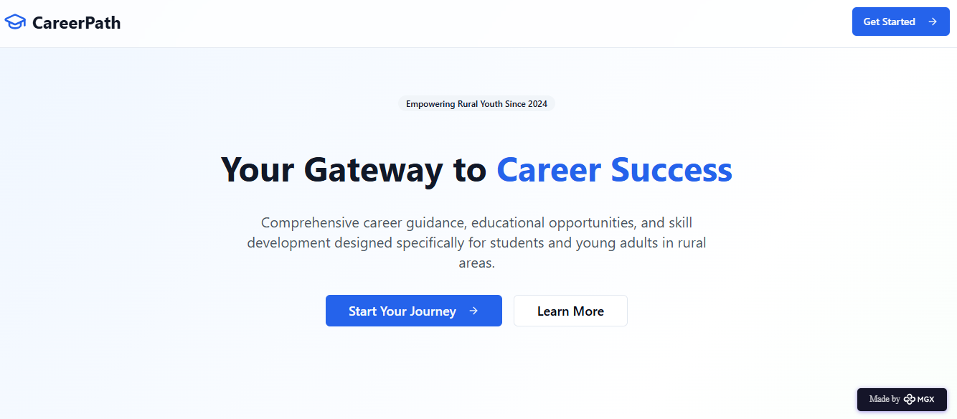

Internal Working of tool:

Profile Creation:

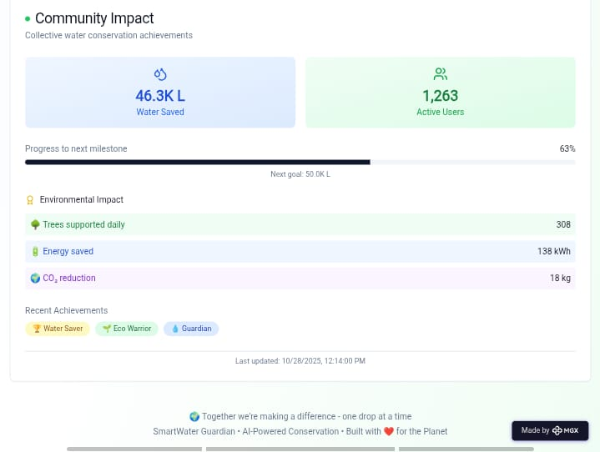

Tailoring recommendations using virtual assistant:

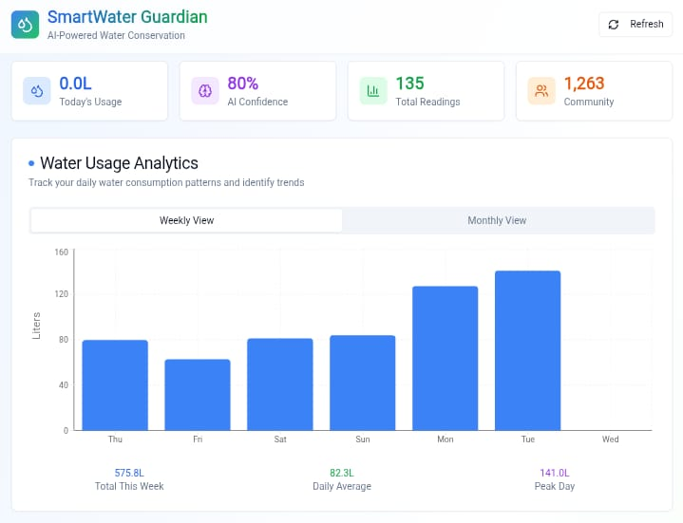

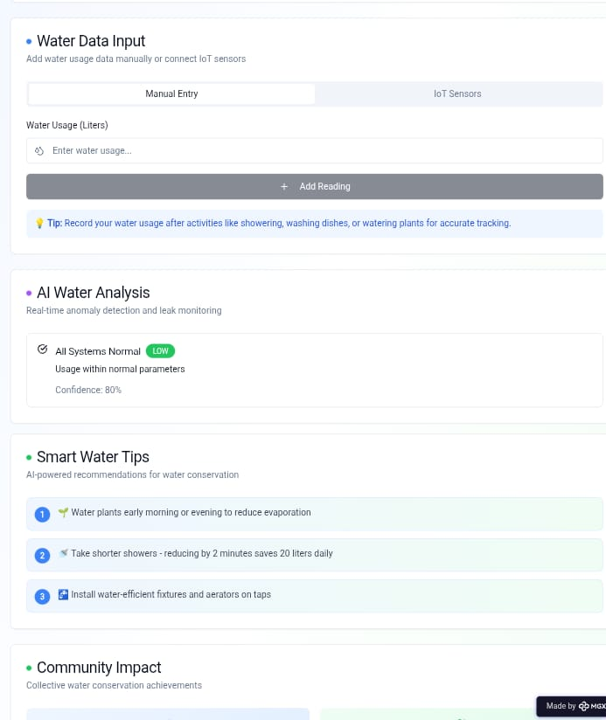



*Step 7: Test – Getting Feedback*

* Who did I share my solution with?

I shared my \***AI for Water Conservation**\* solution with:

**Farmers and rural community members** – to get feedback on usability and how it helps manage water effectively.

**Environmental experts and local government officers** – to understand how well it supports water conservation practices.

**Students and teachers** – to see if it helps in learning about sustainable water usage and AI-based monitoring.

**Peers and mentors** – for suggestions on improving features, design, and awareness impact.What

feedback did I receive?

**Feedback: Pros and Cons**

**Pros (Positive Insights from Feedback):**

1. Users found the AI system helpful for predicting water usage and giving real-time conservation tips.

2. The concept of the platform is *innovative* and shows strong potential for promoting sustainable water management.

3. *Automatic alerts and monitoring features* were appreciated as useful and time-saving tools.

**My Response for The Feedback:**  
AI for Water Conservation* is an idea created using a *no-code tool (Meta MGX). As it’s an initial prototype, the available integrations and sensor data sources are limited. To fully integrate real-time monitoring and predictive features, we would need **collaborations with environmental organizations and water management authorities. The current limitations are due to the prototype setup, but the concept demonstrates the **potential, usability, and social impact* of the solution in promoting sustainable water use.

👍 What works well:

**What Works Well**

* **\* Easy Access & Monitoring:* Users can easily track water usage and conservation tips in real-time through a simple dashboard.**
* **\* ⚙️ *No-Code Development:* Built on Meta MGX, allowing quick updates or modifications without coding knowledge.**
* **\* 🌿 *AI-Based Insights:* The AI model provides *personalized water-saving recommendations* based on usage patterns and environmental data.**
* **\* 📈 *Awareness and Education:* The app helps *spread awareness* about sustainable water practices among students and farmers.**
* **\* 🌍 *Location-Based Suggestions:* Users receive *region-specific water management guidance*, including rainfall alerts and conservation techniques.**
* **\* 📱 *Mobile-Friendly and Accessible:* Designed for *easy navigation* and works even in low-internet rural areas**.

🔧 What needs improvement:

* **\* Sensor Data Delay:* Some water level and usage data updates take time, reducing real-time accuracy.**
* **\* 🧩 *Interactive Features:* Few dashboard options are *not fully responsive* in the prototype version.**
* **\* 🔗 *Integration Limitations:* Needs better connection with *IoT sensors and weather APIs* for complete automation.**
* **\* 🤝 *Collaborations Needed:* To improve data accuracy and reach, partnerships with *government and NGOs* are required.**
* **\* 🎨 *User Experience Enhancements:* Visual design, reports, and alerts could be made *more engaging and user-friendly**ing.

*AI Tools you can use for Step 6-7:*

**ChatGPT/Perplexity AI/Claude AI/Canva AI/Chatling AI/Figma AI/Metamgx/Gamma AI**: You can use these tools to build solutions/models or mock-up dummy prototypes

***Day 4: Showcase***

*Step 8: Presenting my Innovation:*I am presenting **CareerPath**, a **digital career guidance and skill development platform** for rural youth. It features:

* An **AI-powered virtual assistant** that provides personalized career, scholarship, and job guidance.
* **Skill development modules** for English, aptitude, and soft skills.
* **Location-based suggestions** for nearby colleges, training centers, and opportunities.
* A **user-friendly, mobile-friendly interface** built on **Meta MGX** with lifetime access and easy updates.

**Impact:** CareerPath helps students make informed decisions, improves employability, and bridges the guidance gap in rural areas.

**<SHOWCASE YOUR INNOVATION TO YOUR PEERS>**



*Step 9: Reflections*

* What did I enjoy the most during this project-based learning activity?

I enjoyed **building CareerPath using a no-code tool** and seeing my idea take a **real, interactive form**. It was exciting to **design the AI assistant, skill modules, and location-based features**, and imagine how it could **empower rural youth** to make better career decisions.

What was my biggest challenge during this project-based learning activity?

My biggest challenge was **integrating all features smoothly** in the prototype using a no-code tool, especially ensuring the **AI assistant, skill modules, and location-based recommendations** worked together effectively with limited resources.

**Take-home task**

<https://github.com/vijayyadavd890-del/AI-for-water-conservation->

*AI Tools you can use for Step 8:*

**Canva AI:** You can use this to design your pitch document. Download your pitch document as a PDF file and upload on GitHub